Report on Crime Findings in Chicago 2015

**Introduction:**

This report was created to draw attention to Chicago’s 2015 crime trends using Chicago’s Open Data portal. Thefts were the most common crime in 2015, followed by batteries. Battery is defined as “the actual act causing … physical harm [to a human being]”[1]. Theft is the unauthorized control over property.[2] Analytical methods include a bar chart on theft/battery arrest rates, a line graph studying monthly theft/battery trends, and geographic views of theft/battery concentration. Four insights are presented:

1. Thefts and batteries were the highest recorded crimes in Chicago in 2015.
2. Despite high crime rates, arrest rates were low for both batteries and thefts.
3. Batteries and thefts occurred the most during summer months while tourists visited Chicago and events attracted large crowds. Higher crime rates occurred on weekends (Friday/Saturday/Sunday) as well.
4. These crimes were heavily concentrated in the Streeterville and Loop areas, which are tourist and retail attractions.

Based on these insights, the following conclusions are presented to the City of Chicago to increase arrest rates and stay ahead of seasonal trends to combat theft and battery:

* It is recommended the City of Chicago increase the number and quality of security cameras in public spaces to identify suspects and increase arrest rates.
* Furthermore, it is recommended the city publish notices in high-tourist areas and during high-profile events to warn individuals to practice caution when handling valuable items.

**Analysis:**

High Crime, Low Arrest Rates:

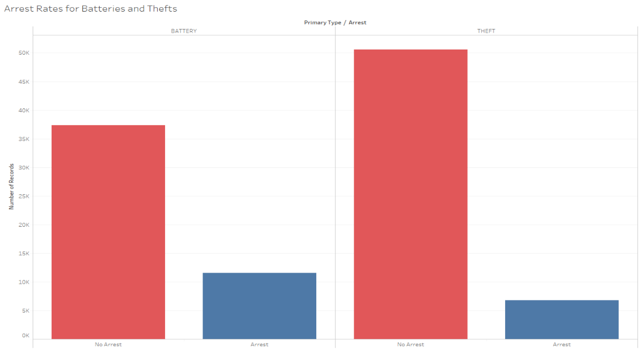 A count of recorded crimes by category found thefts to be the most common, followed by batteries. Thefts accounted for 21.70% of all crimes and batteries accounted for 18.51%. Out of 57,340 recorded thefts, 88% did not result in an arrest. Out of 48,919 recorded batteries, 76% did not result in an arrest. High escape rates leave individuals and businesses at risk of victimization by repeat offenders.

The above suggests it is easier for police to make battery arrests than theft arrests. Depending on a battery’s location, it could be easier for a bystander to intervene and hold an attacker off until police arrive. Furthermore, it is easier for surveillance cameras to capture a battery in action than a theft. A theft includes more veiled activities such as shoplifting and stealing other unattended property nonviolently.[3] These veiled activities may not be captured by security cameras or personnel, especially if the theft occurs in a large crowd where the offender can blend in and escape.

Seasonality:

Large crowds are common in high foot traffic scenarios such as tourist season or high-attendance events. The below graph tracks total batteries and thefts per month for 2015. When broken down, thefts and batteries seasonally occurred. Batteries peaked in May and thefts peaked in August. A significant uptick also occurred in March. Both crimes exhibit similar occurrence rates; as batteries increase, thefts also tended to increase.

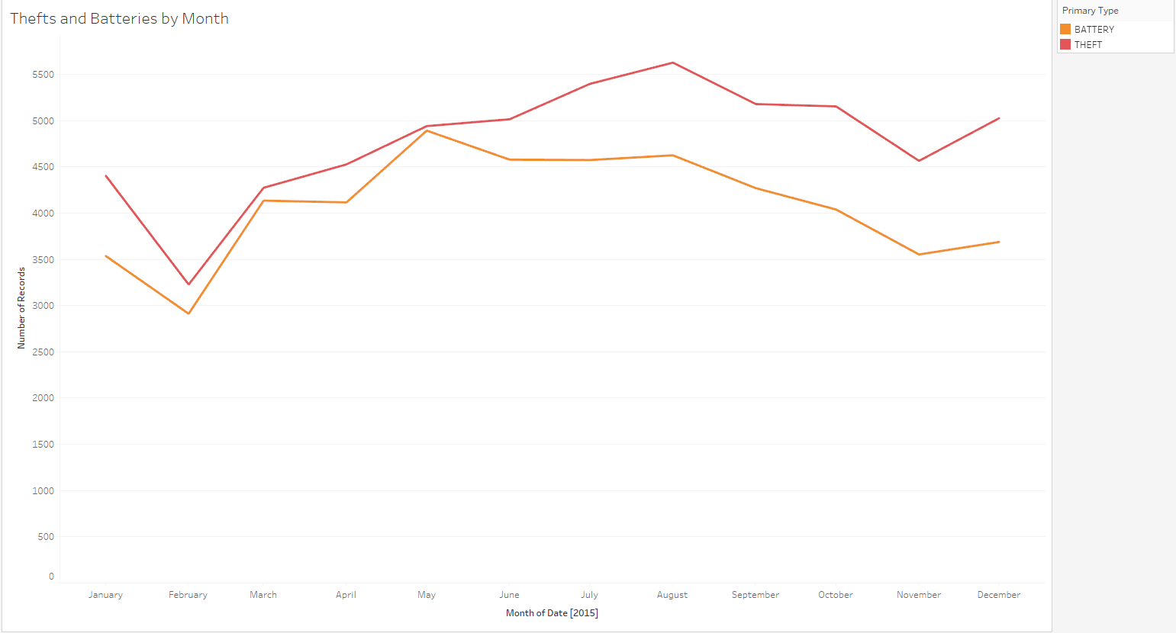

Tourist-driven seasonality may be at play. 2015 saw record tourism numbers surpassing 52 million.[4] Date-level crime analysis aligns batteries and thefts with high-profile events such as the NFL Draft, which occurred in early May[5], as well as Lollapalooza which occurred in early August.[6] March observed the St. Patrick’s Day Parade on Saturday, March 14, which aligns with an increase in batteries, potentially related to increased foot traffic and public drunkenness. Furthermore, batteries and thefts consistently occurred more on weekends (Friday – Sunday). This suggests both crimes occurred when there was increased foot traffic and out-of-town weekend visitors. Heightened foot traffic may lead to increased opportunities both to steal property and commit battery.

Location:

To increase arrest rates and drive preventative measures, it is important to understand where these crimes occur. Below illustrates total recorded batteries and thefts throughout Chicago in 2015. There is a high concentration of both crimes in the Streeterville and Loop areas. These areas are highly concentrated with tourists and high-end retail. Increased foot traffic and retail may explain the concentration of both thefts and batteries in these areas. Particularly, at least 25% of thefts occur in public areas where individuals may roam, such as walkways, streets, or parking lots.

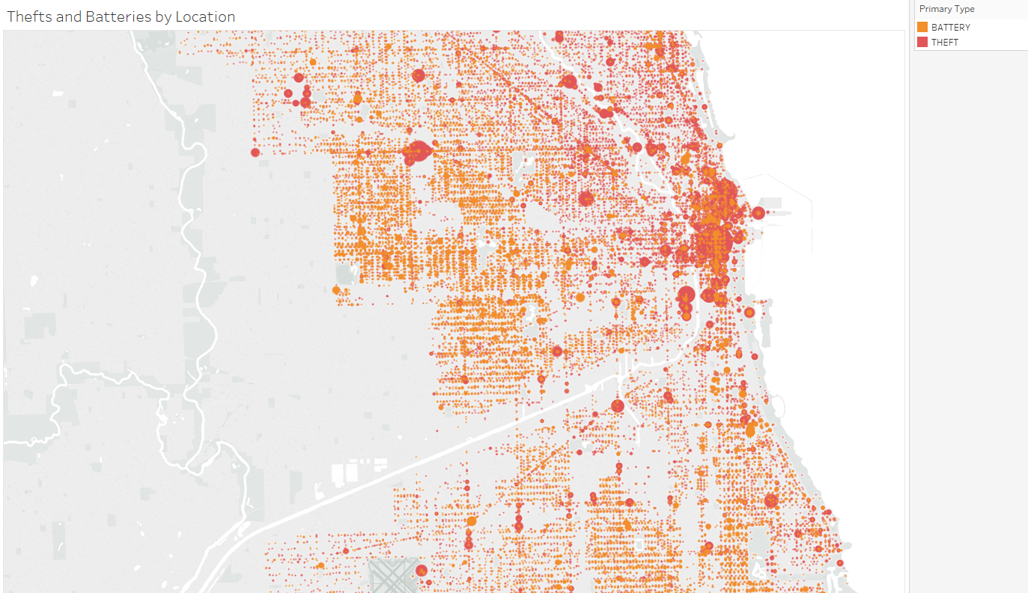

**Conclusions:**

Chicago’s top two crimes in 2015 were battery and theft. These crimes observed low arrest rates, high seasonality, and significant locational concentration. Perpetrators often escaped legal repercussions, which endangered Chicago citizens, businesses and visitors to victimization. This risk increased during high-profile events and on weekends, which generally attract both tourists and locals. Streeterville and the Loop were particularly susceptible to battery and theft as these areas contain a high concentration of retail shops, out-of-town shoppers, and Chicago residents. Accordingly, to ensure the accuracy of this study, further research must be done on 2016-2019 data to confirm whether the patterns observed in 2015 are consistent. Those findings would inform the promotion of the below recommendations to the City of Chicago. Holding all data constant, the below recommendations are presented to the City of Chicago to increase arrest rates and stay ahead of seasonal trends to combat theft and battery:

* Encourage the City of Chicago to increase the number and quality of security cameras in public spaces to identify suspects and increase arrest rates.
* Recommend the city publish notices in high-tourist areas and during high-profile events to warn individuals to practice caution when handling valuable items.

1. Cornell Legal Information Institute. “Assault and Battery”. <https://www.law.cornell.edu/wex/assault_and_battery>
2. Illinois General Assembly. Illinois Compiled Statutes: (720 ILCS 5/16-1). <http://www.ilga.gov/legislation/ilcs/fulltext.asp?DocName=072000050K16-1>
3. Nolo Legal Help. “The Differences Between Theft and Robbery”. <https://www.nolo.com/legal-encyclopedia/differences-between-theft-robbery.html>
4. Office of the Mayor. Mayor Emanuel and Choose Chicago Announce Record Tourism in 2015. <https://www.chicago.gov/city/en/depts/mayor/press_room/press_releases/2016/april/Mayor-Choose-Chicago-Announce-Record-Tourism-2015.html>
5. 2015 NFL Draft to be held in Chicago. <http://www.nfl.com/news/story/0ap3000000404486/article/2015-nfl-draft-to-be-held-in-chicago>
6. Lollapalooza Releases 2015 Festival Lineup. <https://www.nbcchicago.com/blogs/worth-the-trip/lollapalooza-2015-lineup-chicago-297496711.html>